Contents
Introduction 3
Task flow (Fabric workspace element visualization) 4
Medallion architectures 4
Type 1 : 1 workspace 1 Lakehouse and Multiple subfolder (Bronze, Silver , Gold) 4
Type 2 : 1 workspace and Multiple Lakehouse (Bronze, Silver , Gold) 5
Type 3 : Multiple Workspace (Bronze, Silver , Gold) 5
Raw to landing using Notebooks partition and incremental load 5
Scenario: 5
Design 6
Implementation: Create data lake container and folder 6
Implementation: Create notebooks for loading from Row to landing 6
Implementation: Incremental(partition based) loading from Row to landing 7
Implementation: Connection Fabric and datalake 7
Implementation: Orchestration with Fabric pipeline (with parameters) 8
From Landing to Bronze using Notebooks and Lakehouse 8
Architecture - Design 8
Architecture – Notebook -UPSERT-Ing (Insert or update rows) 8
Implementation: Create lake house and notebook 8
From Bronze to Silver layer using Notebooks 9
Architecture - Design 9
Architecture – Notebook -UPSERT-Ing (Insert or update rows) 10
Implementation: Cleaning bronze data 10
Implementation: Some business Logics 10
From Silver to Gold layer using Notebooks 10
Architecture - Design 10
Data model 11

Medaillon architecture

Introduction
The following is an architecture that will help :
- Ingest data from source system to a data lake (Azure Storage account)
- Use notebooks to transform these data and store it’s to Br, sil , gld Lakehouses (layers in the same WS)
- Use data pipelines to orchestrate (execute in given time using parameters) the notebooks and other transformations if needed.
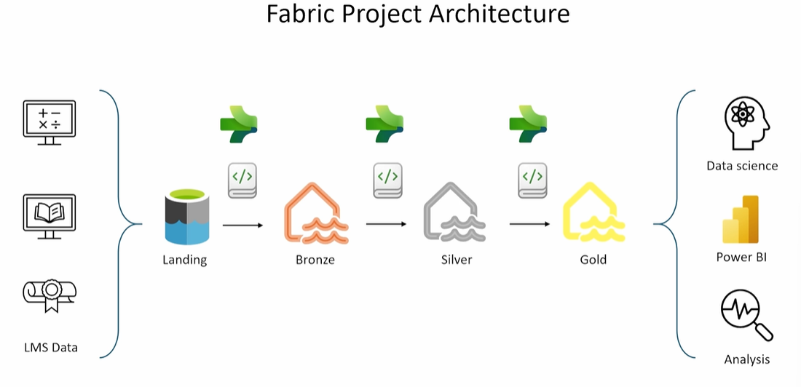
When you create a Workspace , can create a Lakehouse (see below )
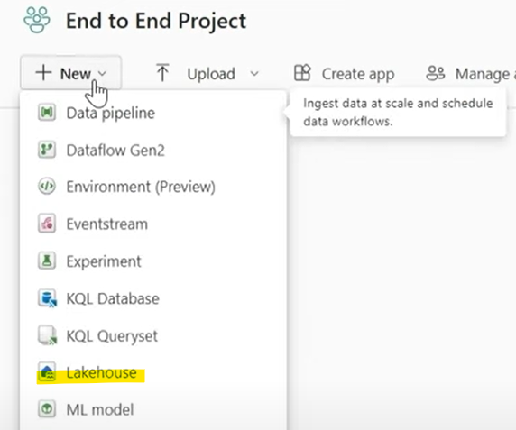
When the lakehouse is created , this provide you to artifacts (objects) automatically (see below)
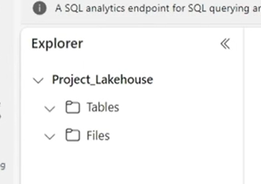

The common usage of these 2 objects is:
- Files folder: Is the area where original files (coming from the source system) will be stored.
- Tables folder: Using notebook, DataFlow , data Pipeline , shortcut the the folder will be populated in delta format (delta tables) with the data from the files folder

Task flow (Fabric workspace element visualization)
https://www.youtube.com/watch?v=zkfSNwDaO-A
https://www.youtube.com/watch?v=3GL_ZA3UnHA

Medallion architectures
Depending on the size of your organization and it data ,the securitry perstictives you can use one of the following types:

Type 1 : 1 workspace 1 Lakehouse and Multiple subfolder (Bronze, Silver , Gold)
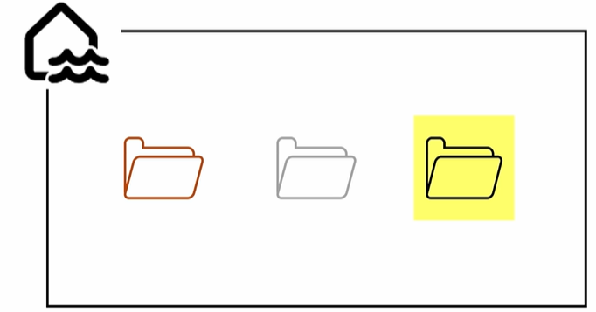

Type 2 : 1 workspace and Multiple Lakehouse (Bronze, Silver , Gold)
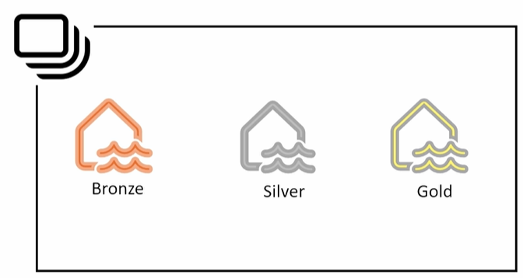
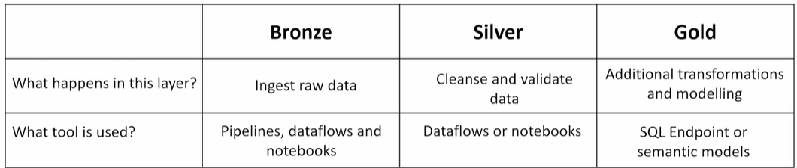

Type 3 : Multiple Workspace (Bronze, Silver , Gold)
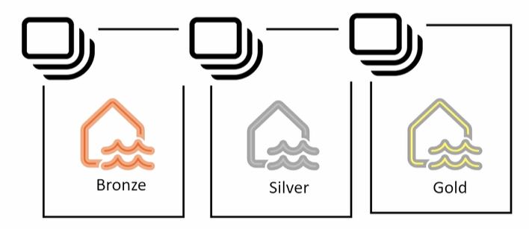

Raw to landing using Notebooks partition and incremental load
https://www.udemy.com/course/master-microsoft-fabric-a-complete-end-to-end-project-cicd/learn/lecture/46197011#overview

Scenario:
Getting data from a website using an API call, and being stored first in the Raw layer , from where using notebooks will be moved incrementally and stored in day partition structure.
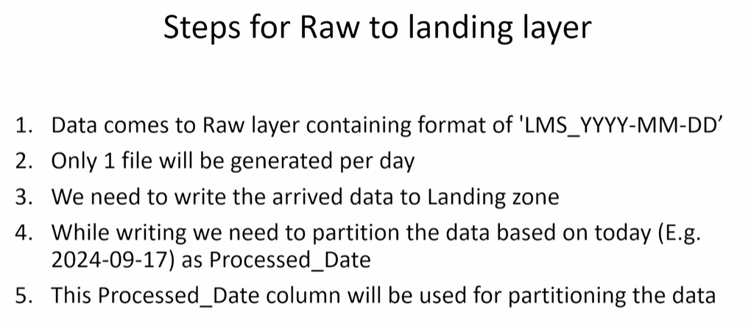

Design
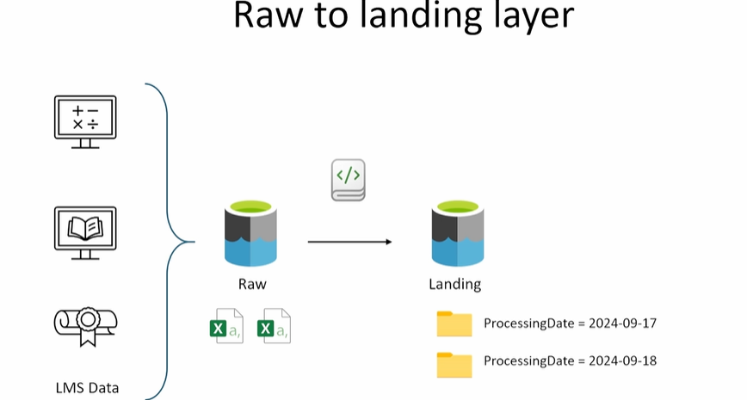

Implementation: Create data lake container and folder
Ref: https://www.udemy.com/course/master-microsoft-fabric-a-complete-end-to-end-project-cicd/learn/lecture/46197011#overview (From min 5)

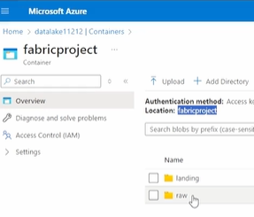

Implementation: Create notebooks for loading from Row to landing
https://www.udemy.com/course/master-microsoft-fabric-a-complete-end-to-end-project-cicd/learn/lecture/46197015#overview (from 1:50 min)

Implementation: Incremental(partition based) loading from Row to landing
https://www.udemy.com/course/master-microsoft-fabric-a-complete-end-to-end-project-cicd/learn/lecture/46197059#overview
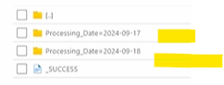

Implementation: Connection Fabric and datalake
https://www.udemy.com/course/master-microsoft-fabric-a-complete-end-to-end-project-cicd/learn/lecture/46197067#overview (from 1,30 min)
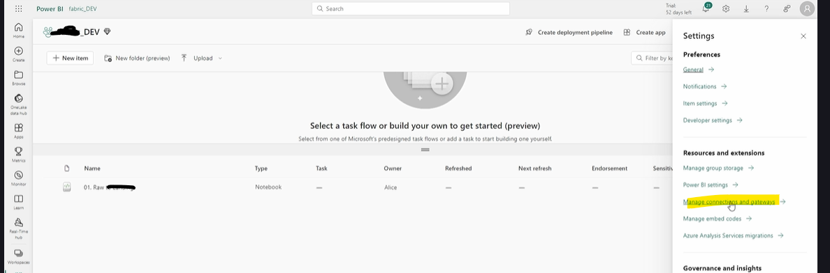

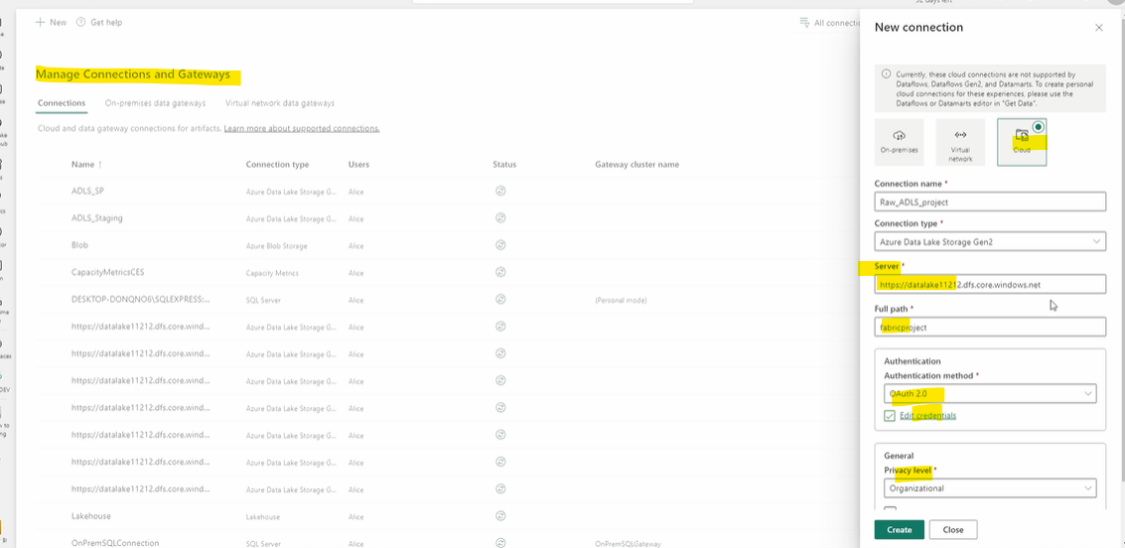

Implementation: Orchestration with Fabric pipeline (with parameters)
https://www.udemy.com/course/master-microsoft-fabric-a-complete-end-to-end-project-cicd/learn/lecture/46197067#overview (from 3,16 min)
Note: Fabric pipeline will be orchestrating data movement from Raw to Landing (both located in datalake)

From Landing to Bronze using Notebooks and Lakehouse

Architecture - Design
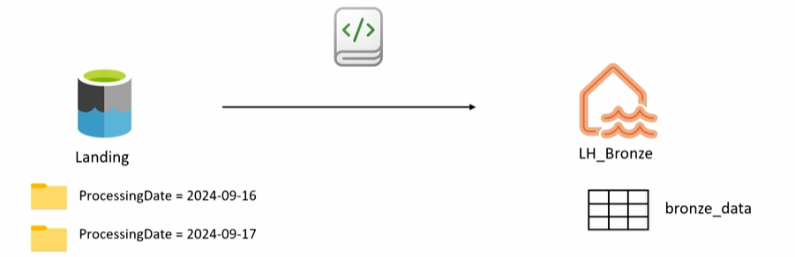

Architecture – Notebook -UPSERT-Ing (Insert or update rows)
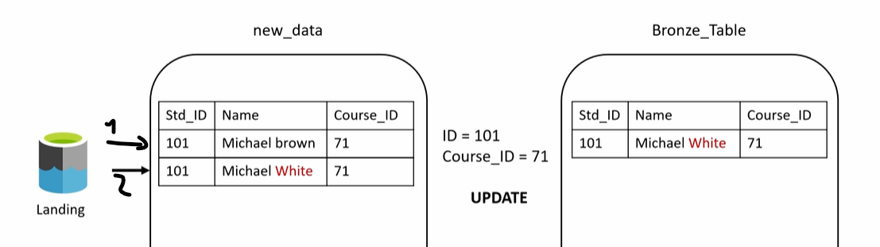

Implementation: Create lake house and notebook
https://www.udemy.com/course/master-microsoft-fabric-a-complete-end-to-end-project-cicd/learn/lecture/46197081#overview
Steps:
- Create a dev Lakehouse
- Create a notebook
- Attach the notebook to the Lakehouse
- In the notebook read the data from the source file into a view (v1)
- Create a table(t1) (delta) if not exists yet with the same schema as the previous view (v1)
- Create a view v2 on top of the delta table t1
- Compare the 2 view v1 and t1, if line from v1 not exists in t1 insert it t1 , but if it exists already updated in t1

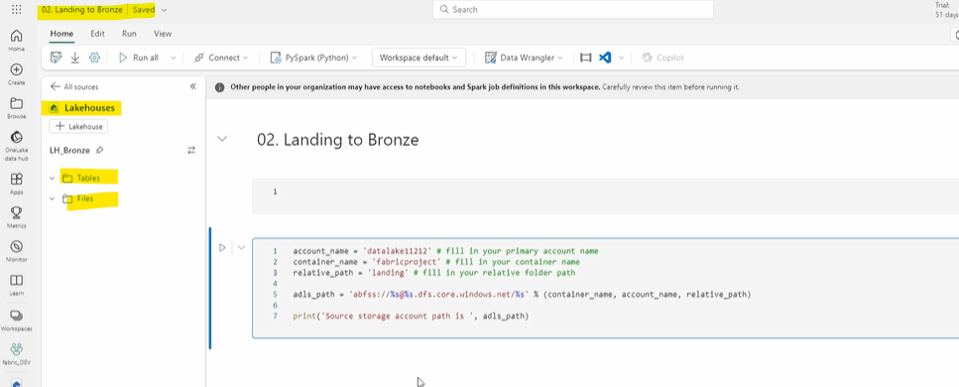

From Bronze to Silver layer using Notebooks

Architecture - Design

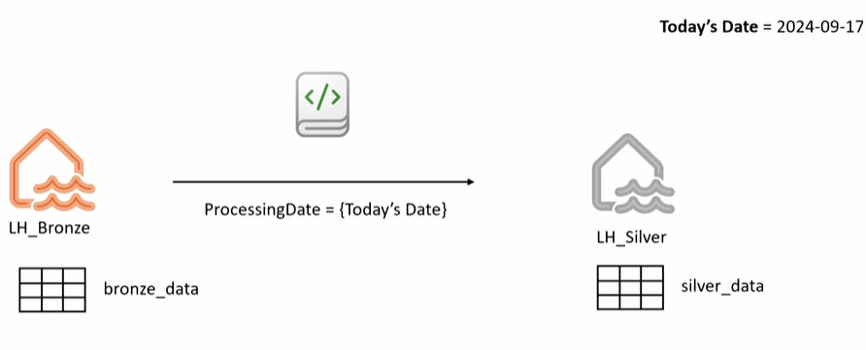
In this scenario we will be transforming and loading data into Silver Layer from Bronze layer. These transformations could be :
- Data Quality enhancement
- Renaming some columns
- Removing not needed columns
- Applying some business logics...

Architecture – Notebook -UPSERT-Ing (Insert or update rows)
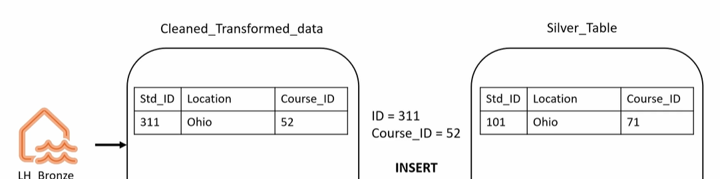

Implementation: Cleaning bronze data
https://www.udemy.com/course/master-microsoft-fabric-a-complete-end-to-end-project-cicd/learn/lecture/46197141#overview
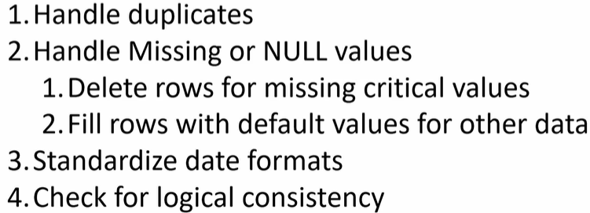
(from 2:58)

Implementation: Some business Logics
https://www.udemy.com/course/master-microsoft-fabric-a-complete-end-to-end-project-cicd/learn/lecture/46197175#overview
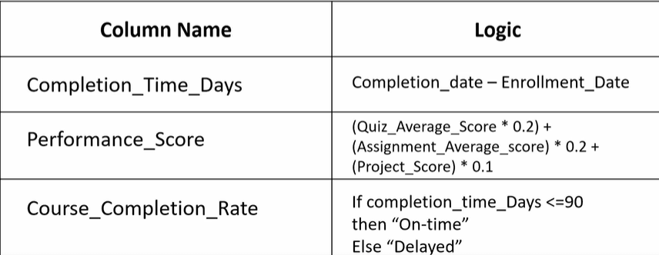

From Silver to Gold layer using Notebooks

Architecture - Design

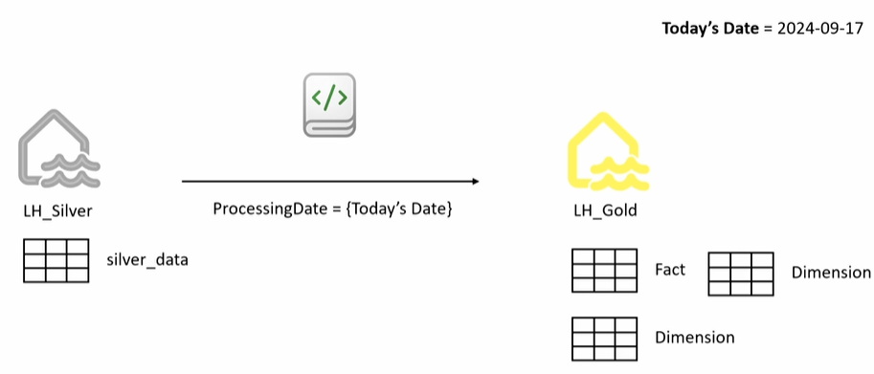

Data model
https://www.udemy.com/course/master-microsoft-fabric-a-complete-end-to-end-project-cicd/learn/lecture/46197215#overview
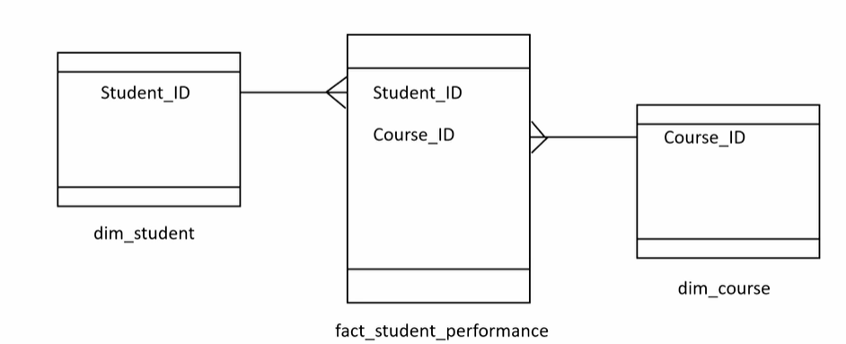
The following step are applicable to all fact and dimensions :
Step 1: Create a schema
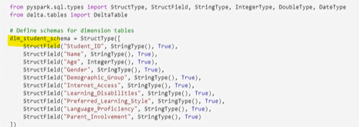
Step 2: create a delta table using the schema
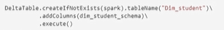
Step 3: fill the table with data according to business needs
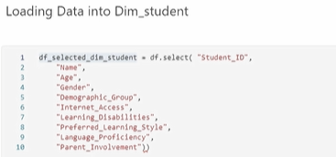
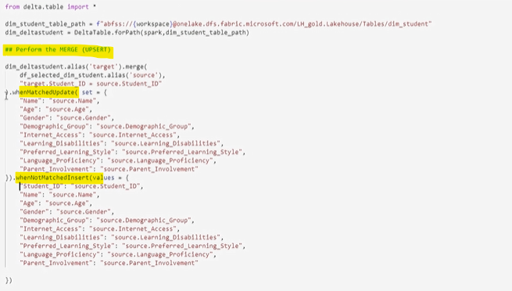
After running some metrics will be available :
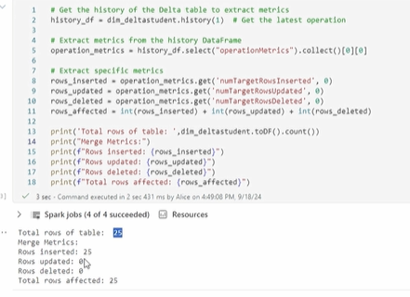

Semantic model Power BI / Power BI Desktop
https://www.udemy.com/course/master-microsoft-fabric-a-complete-end-to-end-project-cicd/learn/lecture/46197221#overview
Starting from the Gold Lakehouse where we have the fact and dimensions tables, create the Semantic model.
The following steps are important:
Step1: from the Gold Lakehouse access the SQL end point , there you will be able to see the model (All table) and also create a custom Semantic model.
Step2: When a model is created (tables with relationships) this is accessible from PBI desktop for building reports on top of it.

Step3: When reports are been created they can be published to the WS created from the begin of this course.
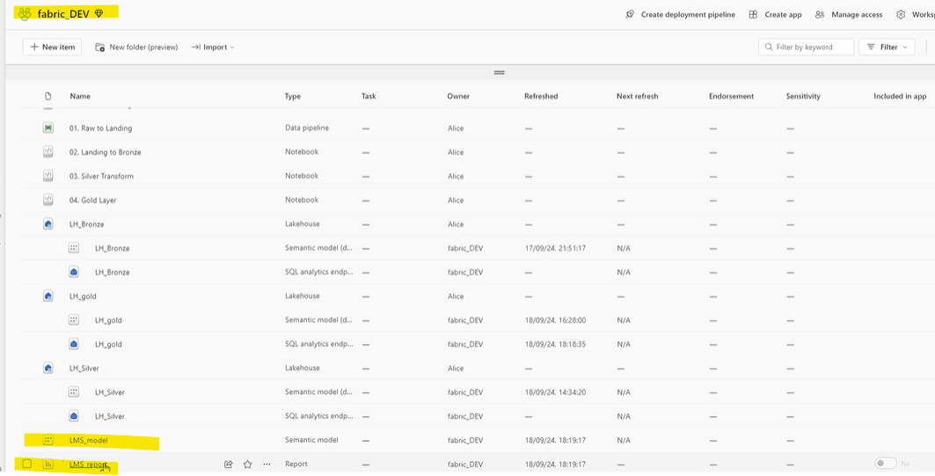

All steps is a single orchestration
https://www.udemy.com/course/master-microsoft-fabric-a-complete-end-to-end-project-cicd/learn/lecture/46197229#overview

Note : Invoking an already existing Pipeline, you will need to create a connection (4e min)
